Macintosh HD:Users:erinturner:Downloads:Top Star Logo Tumbling Tramp Cheer.pdf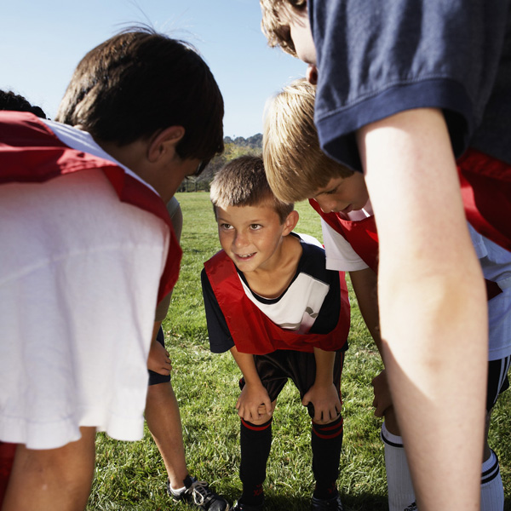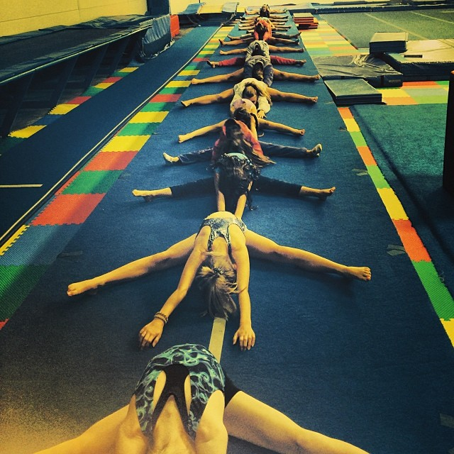

for the parents! Cubbies are now in the addition for the rec kids. The old office is now a locker room for competition team athletes only. In the future we hope to offer Wi-Fi as well as hang TV’s in the viewing area!! Bear with us as all the final touches are put into place!

## New Addition Info

As I’m sure you’ve noticed, we have another new addition to our gym! The continued growth of Top Star has given us the opportunity to expand and better our gym time and time again! Anyone wishing to view practice will now do so from behind the windows in the new lobby. The office and payment box will also be moved to the new addition for easy access

# Our goal in writing monthly newsletters is to provide parents and athletes with valuable information. They will typically include: gym information, changes in schedule, upcoming competitions, past competition results and much more! We hope you find our newsletters entertaining and informative!

Top Star Newsletter

January 2014

**Competition Trampoline & Tumbling Team**

January Birthdays!

*** Birthdays

January 17th: Ava King

January 19th: Alyssa Whitlock

January 24th: Josie Cler

January 26: Destiny Rowan

January 29th: Ardita Veseli

January 31st: Delaney Walsh

January 5th: Clementine Craft, Mikayla Evans, Phoebe Lewis

January 6th: Eve Detweiler

January 7th: Mary Beth Franey, Haley Ohlsson

January 11th: Jeriah Jones

January Birthdays!

If you see any of these kids around the gym this month, wish them a happy birthday!

Come Ready to Participate!

The temperature in the gym is difficult to predict – dress your athlete in layers, including a leotard, shorts, sports pants, sweatshirts and socks (nothing too baggy). This will keep your athlete comfortable throughout the practice period. We have practice-appropriate shorts and leggings available for sale in the office. Shorts are $15 and leggings are $20. We do our best to maintain a comfortable atmosphere for our athletes. While it may feel chilly to many, we can assure you that the kids are comfortable while they are working!

We ask that parents please put your child’s hair up in a tight ponytail before practices. For longer hair a tight bun is ideal; for short hair please pull at least the top back into a half pony. This has been an ongoing issue in the gym. Too many athletes are missing turns and distracting the coaches because they need their hair pulled up. We do not allow the kids to tumble with their hair in their face, as it is a safety hazard. Thank you for your cooperation on this matter.

## Hair

## Water Bottles

Starting in January Top Star will no longer have a water jug available to the athletes. All athletes need to bring their own water bottle to practice. We have a brand new sink with filtered water if they need to refill their bottle, but we will no longer provide cups or the Hinckley Springs water jug. We are sorry for the inconvenience.

### Upcoming January Competitions

Our first Trampoline and Tumbling competition of the season was held in Crown Point, Indiana! Though we only took a few athletes, it was a huge success!

Delaney Walsh: 1st on trampoline & double mini

Bri Struck: 1st on floor, 2nd on trampoline & double mini

Meredith Hogue: 1st on floor, 3rd on double mini

Riley Kofoed: 1st on trampoline & floor, 2nd on double mini

Olivia King: 2nd on floor, 5th on trampoline & double mini

Payton Turk: 2nd on double mini, 3rd on floor and 4th on trampoline

Taylor Hannagan: 1st on floor & double mini, 3rd on trampoline

Melissa Singleton: 2nd on floor, 4th on double mini and 5th on trampoline

## December Meet Results!

* Sunday January 12th: Cheer competition in Mattoon, Illinois
* Sunday January 26th: Cheer competition in Effingham, Illinois
* Sunday January 26th: USAG Trampoline and Tumbling competition in Dyer, Indiana

## Upcoming Competitions

Missy has been involved in the sport of gymnastics for over 30 years. Missy was a competitive gymnast in her home state of Minnesota and began coaching when she was 18 years old. She has had extensive training in many different courses and clinics in gymnastics.

Missy has been involved in the sport of Trampoline and Tumbling for 12 years as a coach and is certified to judge tumbling.

Missy coaches the competition team classes but likes to float around to get to know her athletes in every level!

Missy resides in Humboldt, IL with her husband, Ryan, and their three children, Raea, Braden and Jakob.

Meet the Coach!

Missy Weder

Gym owner, head coach

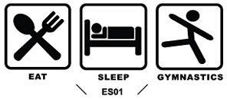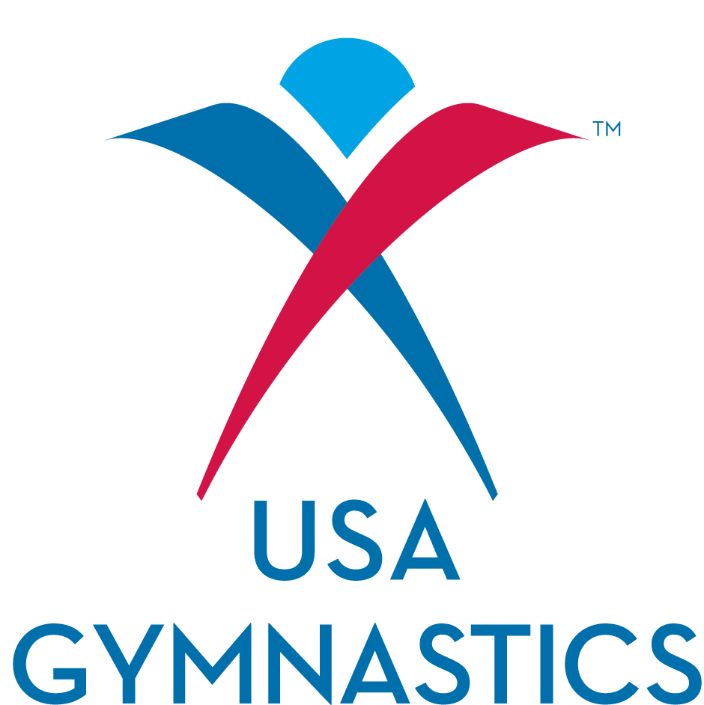

## Sick Kid?

It’s flu season! If your child is sick on tumbling day, please use your best judgment as whether to bring him or her to class. Definite no-no’s include the infamous green runny nose and recent or current fever. We know some kids don’t like to miss class but we are more than happy to offer make-ups in an available class of the same level. To arrange a make-up, see your child’s teacher or call us!

Eat Sleep Tumble

We will be hosting a pizza party for Top Star members on Friday, January 24th! The party will run from 6:00 to 9:00 and will be $15 per child. If you plan on attending, please sign your child up on the sign-up sheet by the office. No siblings or friends, Top Star members only please! We look forward to seeing you!

## Pizza Party!

**Top Star Training Center**

1708 W. Hensley Rd

Champaign Illinois

217-378-5058

topstargym.net

topstargym@hotmail.com

#### We are so proud of our athletes, parents and coaches. Thank you for your dedication, loyalty and support in helping us create a successful and confident family atmosphere.